TRIBHUVAN UNIVERSITY

**PATAN MULTIPLE CAMPUS**

PATAN DHOKA, LALITPUR

**C PROGRAMMING (BIT 102)**

**LAB 1**

|  |  |
| --- | --- |
| **SUBMITTED BY** | **SUBMITTED TO** |
|  |  |
| NAME: SURESH DAHAL | DADHI RAM GHIMIRE |
| CLASS: BIT – I/I |  |
| ROLL NO: 23 | ………………………… |
| DATE: 2080/10/07 | CHECKED BY |

1. **Write a C program to print your name, date of birth and mobile number using printf() and puts() functions.**
2. **ALGORITHM**

**STEP 1:** Start

**STEP 2:** Print name, date of birth and mobile number using printf function

**STEP 3:** Print name, date of birth and mobile number using puts function

**STEP 4:** Stop

1. **FLOWCHART**

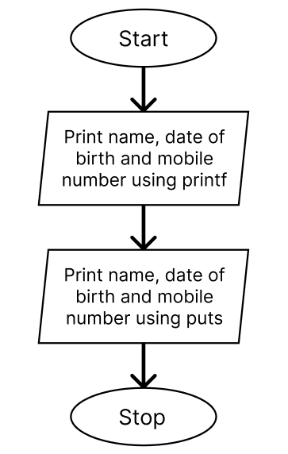

1. **PROGRAM**

#include<stdio.h>

int main() {

printf("Name: Suresh Dahal\nDate of Birth: 1999/01/01\nMobile: 9841234567\nAddress: Kathmandu\n");

puts("\nName: Suresh Dahal\nDate of Birth: 1999/01/01\nMobile: 9841234567\nAddress: Kathmandu\n");

return 0;

}

1. **OUTPUT**

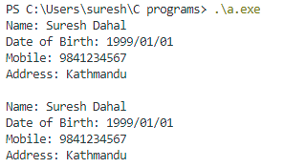

1. **Write a C program to display size in bytes of different data types using sizeof() operator.**
2. **ALGORITHM**

**STEP 1:** Start

**STEP 2:** Print size of different data types using sizeof() operator

**STEP 3:** Stop

1. **FLOWCHART**

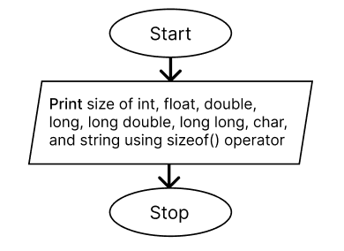

1. **PROGRAM**

#include <stdio.h>

int main() {

char name[20];

    printf("Size of char: %d\n", sizeof(char));

    printf("Size of int: %d\n", sizeof(int));

    printf("Size of float: %d\n", sizeof(float));

    printf("Size of double: %d\n", sizeof(double));

    printf("Size of long: %d\n", sizeof(long));

    printf("Size of long long: %d\n", sizeof(long long));

    printf("Size of long double: %d\n", sizeof(long double));

    printf("Size of name string: %d\n", sizeof(char name[10]));

    return 0;

}

1. **OUTPUT**

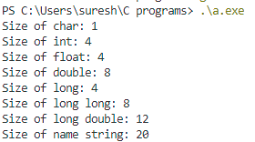

1. **Write algorithm, flow-chart and program to compute the area and circumference of a circle with given radius r as input defining as constant (Note: Area=πr2)**
   1. **ALGORITHM**

**STEP 1:** Start

**STEP 2:** Define PI

**STEP 3:** Declare variables r, area, and circumference with float type

**STEP 4:** Calculate area = PI * r * r and circumference = 2 * PI * r

**STEP 5:** Print area and circumference

**STEP 6:** Stop

* 1. **FLOWCHART**

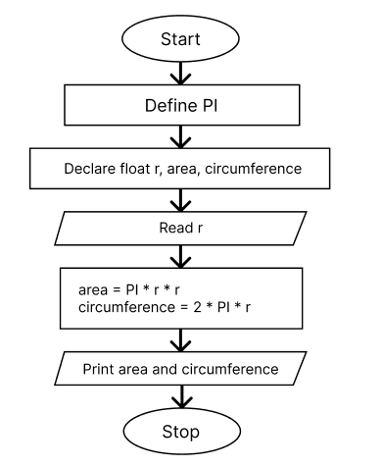

* 1. **PROGRAM**

#include <stdio.h>

int main() {

    float r, area, circumference;

    printf("Enter radius of circle: ");

    scanf("%f", &r);

    area = 3.14 * r * r;

    circumference = 2 * 3.14 * r;

    printf("Area of circle: %f\n", area);

    printf("Circumference of circle: %f\n", circumference);

    return 0;

}

* 1. **OUTPUT**

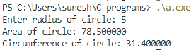

1. **Write a C program to convert specified no of days into years, months, weeks and days. (Note: Ignore leap year.)**
   1. **ALGORITHM**

**STEP 1:** Start

**STEP 2:** Declare variables total_days, years, months, and weeks

**STEP 3:** Read total_days

**STEP 4:** Find years, months, weeks and days as:

years = total_days/365

total_days %= 365

months = total_days/30

total_days %= 30

weeks = total_days/7

total_days %= 7

**STEP 5:** Print years, months, weeks and total_days

**STEP 6:** Stop

* 1. **FLOWCHART**

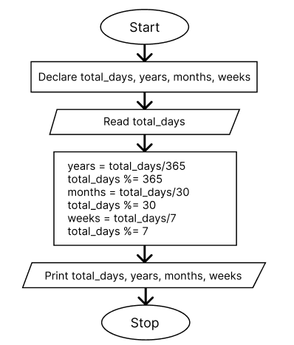

* 1. **PROGRAM**

#include <stdio.h>

int main()

{

    int total_days, years, months, weeks;

    printf("Enter total days: ");

    scanf("%d", &total_days);

    years = total_days / 365;

    total_days %= 365;

    months = total_days / 30;

    total_days %= 30;

    weeks = total_days / 7;

    total_days %= 7;

    printf("Years: %d\n", years);

    printf("Months: %d\n", months);

    printf("Weeks: %d\n", weeks);

    printf("Days: %d\n", total_days);

    return 0;

}

* 1. **OUTPUT**

